**Ranked 8th in Global Finals of Shing-Tung Yau Science Award (Economics), 2022.**

**Abstract**

**Is Transportation Restriction the Original Sin of Economy Downturn? Empirical Evidence from the Epidemic in YRD**

**Xiang(Oscar) Wan (First Author)**

**Nanjing Foreign Language School, China**

In order to combat the covid epidemic, several city governments have implemented the transportation restriction policy, which, according to latest studies, can lower logistics and subsequently the GDP. The transportation restriction may negatively impact the economy in two ways: the short-term/reversible effect and the long-term/irreversible effect. Typically, it is hard to distinguish between these two effects and identify which one is bigger. This study attempts to solve this question by analyzing the epidemic that occurred in the Yangtze River Delta (YRD) in March 2022. We gathered cargo transportation data from China's leading platform for river shipping business. The difference-in-differences (DID) method is utilized to compare the impact of transportation restriction on river shipping amount inside and across YRD. We find that the long-term/irreversible effect of transportation restriction harms the economy more than short-term/reversible effect. The result indicates that people's expectations and confidence regarding the restriction policies are more detrimental to the economy. In the post-epidemic period, these findings have major academic and practical contributions, and they show that individuals must clearly comprehend government’s anti-epidemic measures and make economic activity decisions rationally.-- Title: Is Transportation Restriction the Original Sin of Economy Downturn? Empirical Evidence from the Epidemic in YRD --

1. **Introduction**

As we know, logistics plays a crucial role in the national economy. It allows the exchange of goods inside the country and promotes the expansion of industries by guaranteeing the availability of raw resources. Since January 2020, the novel coronavirus, Covid-19, has spread internationally, and its effects on various sectors of our society, particularly the economy, have been quite severe.

In order to combat the epidemic, many city governments have implemented the transportation restriction policy. Although the policy is highly effective at preventing the spread of the disease, it also decreases the cargo transportation greatly.

The latest studies show that transportation restriction can impede logistics and proceed to affect GDP (Chen et al., 2021). To be specific, transportation restriction lower truck traffic by 54%, and it is anticipated that a full-scale transportation restriction on the four largest cities in China for one month would reduce GDP by 8.6% (Chen et al., 2022).

1. **Literature Review**

Through reading literature of lockdown policy effect on economy, we find out that transportation restriction can harm the economy in two ways.

One is through the short-term and reversible effect, i.e. the transportation restriction may cause a temporary declination in consumption demand, but it will recover quickly once the transportation restriction is lifted.

Another way is the long-term and irreversible effect, i.e. the transportation restriction may lead to the drop in expectation, confidence, and even panic, which reduces the investment demand. This effect is irreversible after the ending of transportation restriction.

Table 1 contains a listing of literatures that discuss the impact of lockdowns on the economy. International effects, like reduced domestic labor supply are not reported in this table. And long-term impacts of the lockdown, such as unemployment, lost educational chances, etc., are not included in this table.

Even though numerous studies have examined both short-term/reversible effect and long-term/irreversible effect, these two effects are always mixed up. So it is hard to differentiate them and examine which one is more significant. In this study, we try to explore this question.

**Table 1. Lockdown influencing mechanism on economy.**

|  |  |  |
| --- | --- | --- |
| Effect | Literature | Detailed mechanism |
| Short-term  and  reversible effect | Alexander & Karger (2020) | reduced spending |
| Adams-Prassl *et al.* (2020) | reduced working hours |
| Ai *et al.*(2022)  Birinci *et al.*(2021) | stopped production (factories) |
| Chen *et al.*(2021) | less transportation and travel |
| Long-term  and  irreversible effect | Brodeur *et al.*(2021) | panic and stress (individuals) |
| Auray & Eyquem(2020)  Chen *et al.*(2022) | reduced aggregate demand |
| Chen *et al.*(2021) | consuming confidence shaken |
| Coibion *et al.*(2020) | household expectations |

1. **Research Settings**

**3.1. Nature Event Selection**

As is well known, a widespread epidemic broke out in Shanghai in 2022 and rapidly spread to most cities in YRD, including Hangzhou, Suzhou, Nanjing, Yangzhou, Hefei, Wuhu, etc. In order to slow down the spread of the coronavirus, the transportation restriction policy was strictly implemented in YRD area. During the transportation restriction period, people, vehicles, and trains cannot enter or exit cities freely. This epidemic event and the transportation restriction measure create ideal research setting for examining the effects of the transportation restriction on the economy.

Secondly, the YRD epidemic originated in Shanghai, a service-oriented city. Up to year 2021, the third industry in Shanghai contributes 73.3% of its GDP. On the other hand, the YRD region’s economy is manufacturing-based. So, Shanghai's central city's economic influence on YRD must be expressed through investment shrivel in the YRD.

**3.2. Dataset**

As noted previously, logistics reflects domestic economy status through real-time behavior data of consumption demand and investments demand. In addition, the logistic industry is also one important link among supply chain. To be specific, logistic stoppage is a main influencer of economy: it decreases consumption demand and investments demand by itself.

Due to the nature of River Shipping data, we are able to separate the cause and effect of transportation data to determine the net effect of transportation restriction policies on the economy.

During the terrible outbreak, the railroad and road transportation were restricted, but river shipping was not. This is because river shipping can achieve non-touching transportation, which allows cargo to be loaded and unloaded without human interaction. The crew member can remain on board without making touch with the people on the port. In conclusion, River Shipping transportation is NOT directly affected by transportation restriction policy. Therefore, it provides a better indication of the net effect of transportation restriction on the economy.

Another characteristic of river shipping data is that the majority of river shipping cargo consists of production materials. This can better reveal investment demand rather than consumption demand. In contrast, truck and train transportation are mixtures of both materials.

As a result, we gathered the data from China's first and largest platform for matching ships and cargoes. Different with DiD matching passengers and taxis, this platform concentrates primarily on river transportation. On the platform, cargo owners register their shipping requirements, such as transferring 10 tons of oil from Suzhou to Shanghai. The shipowners can bid for the deal. Since this platform has a monopoly in this emerging business, its data is highly indicative of the status of domestic trade, particularly for bulk cargoes and industrial products.

We collected all of the data on this platform from 2022-02-16 to 2022-05-31 at deal level across the whole China. For each deal, the information includes: departure city, destination city, cargo name, landing date, money amount of cargo (in RMB) etc. The popular products include coal, steel, ironstone, cement, oil etc. Industrial raw materials account for 88% of the total cargo's monetary value and 97% of the deals.

This design controlled all short-term/reversible effect, as listed in Table 2.

**Table 2. Controlled short-term/reversible effect.**

|  |  |  |
| --- | --- | --- |
| **Short-term/reversible effect** | | **Reason of control** |
| reduced spending | River shipping cargos are almost all production material | |
| reduced working hours | one month working hour reduce has few effect on residence spendable income | |
| stopped production (factories) | YRD didn't apply whole city lockdown policy, only infected streets were locked down, factory manufacturing were not affected | |
| less transportation and travel | Other than road and railway, river shipping were not restricted. River shipping data should not be affected. Furthermore, cargo transportation should shift over from road and railway to river, if there is no significant economy downturn. | |

**3.3. Research method**

The difference-in-differences (DID) analysis is used to determine whether YRD transportation restriction has a long-term/irreversible influence on the economy and how severe the effect is.

A severe epidemic occurred in Shanghai in March 2022 and spread to a number of regions in YRD. Many cities in YRD began to gradually restrict the transportation with the increasing number of infections. As depicted in Table 3, peak arrivals of infected patients occurred between April 17 and April 23, 2022. From that week the strictest restriction policy was adopted in YRD, hence we adopt April 17 as the starting date of the YRD's shipping cargo transportation restriction.

**Table 3. Infection numbers in YRD.**

|  |  |
| --- | --- |
| Week | Infection Numbers in YRD |
| 2022/03/27~04/02 | 1846 |
| 2022/04/03~04/09 | 4427 |
| 2022/04/10~04/16 | 11502 |
| 2022/04/17~04/23 | 23328 |
| 2022/04/24~04/30 | 23186 |

**3.4. Observations**

1) River shipping amount related YRD (related YRD) = River shipping amount inside YRD + River Shipping amount across YRD

2) River shipping amount across YRD (across YRD) = River shipping amount from outside to YRD + River shipping amount from YRD to outside

3) River shipping amount inside YRD (inside YRD)

4) River shipping amount outside YRD (outside YRD)

**3.5. Descriptive Statistics**

Table 4 presents the descriptive statistics of river shipping amount (logged) at week-region level in Panel A and at daily-city level in Panel B. We can clearly find that the river shipping amount is different in regions related YRD, inside YRD, across YRD and outside YRD. In particular, although the number of river shipping deals inside YRD is higher than that across YRD (477 vs. 388), the later has a larger average amount per transaction (12.482 vs. 12.972).

**Table 4. Dataset Summary.**

|  |  |  |  |  |  |
| --- | --- | --- | --- | --- | --- |
| lnamount | N | Mean | St. Dev. | Min | Max |
| Panel A. Week-Region level | | | | | |
| related YRD | 15 | 17.736 | 0.633 | 16.691 | 18.897 |
| inside YRD | 15 | 16.838 | 0.827 | 15.683 | 18.167 |
| across YRD | 15 | 17.109 | 0.638 | 16.180 | 18.240 |
| outside YRD | 15 | 16.446 | 0.688 | 14.938 | 17.627 |
| Panel B. Daily-City level | | | | | |
| related YRD | 865 | 12.702 | 1.291 | 7.513 | 17.641 |
| inside YRD | 477 | 12.482 | 1.281 | 8.985 | 17.641 |
| across YRD | 388 | 12.972 | 1.252 | 7.513 | 17.616 |
| outside YRD | 332 | 12.775 | 1.186 | 9.238 | 16.495 |

**3.6. Hypothesis**

First, we conclude from the literature that transportation restriction has a long-term/irreversible impact on the economy. This is the basis for the development of Hypothesis 1.

*H1: After YRD transportation restriction, river shipping amount related to YRD decrease significantly*

Secondly, we want to determine the distinction between across YRD and within YRD. We assume that due to information asymmetry, long-term effect like confidence shaken and expectation decline would be stronger outside YRD, l resulting in a larger decline in river transport volume across YRD than that inside YRD. The result may reveal the weight of short-term restriction effect vs long-term restriction effect.

*H2: River shipping amount across YRD falls more than river shipping amount inside YRD*

4. Research Findings

**4.1. River shipping amount related to YRD**

Figure 1 shows the River Shipping amount (logged) related to YRD (including the amount inside and across YRD) and outside of YRD at week level. Week 1 in the horizontal axis denotes 2022-2-16 to 2022-2-22, week 2 denotes 2022-2-23 to 2022-3-1, etc.

We can find that the river shipping amount related to YRD is significantly greater than the amount of river shipping outside of YRD in most of the weeks before the beginning of the transportation restriction. But after the starting date, the River Shipping amount related YRD becomes only slightly higher than that outside of YRD.

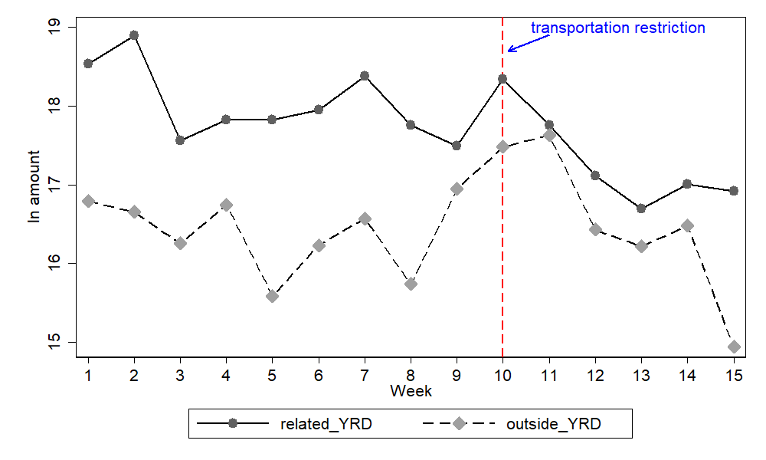

**Figure 1. Trade amount related to YRD vs outside YRD**

In order to strictly validate if the River Shipping amount related YRD decreases after the transportation restriction starting date. We take the river shipping amount outside of YRD as the control, and run the following difference-in-differences regression at week-region level

$\begin{aligned}{lnamount}_{it}=α+β_{1}{related_{YRD}}_{i}+β_{2}{after_{restrict}}_{t}+β_{3}{related_{YRD}}_{i}*{after_{restrict}}_{t}+ε_{it}\#\left(1\right)\end{aligned}$

where ${lnamount}_{it}$ is river shipping amount (logged) in region *i* in week *t*, ${related_YRD}_{i}$ is a dummy equal to 1 if region *i* is related to YRD, 0 if region *i* is outside YRD, ${after_restrict}_{t}$ is an indicator variable that takes on the value 1 for weeks in or after April 20 to 26, 2022. The parameter of interest is $β_{3}$, which is the reduced-form effect of the transportation restriction in YRD on river shipping amount, capturing the difference in the changes in river shipping amount before and after the transportation restriction between the YRD related regions and non-YRD related regions.

To obtain more precise causal inference, we also identify the effect of transportation restriction using daily-city level data using equation (1), and we further control for the weekend fixed effect and month fixed effect.

Table 5 presents the regression results. In column (1), we conduct the regression with region-week level data. The coefficient of the double interaction *related_YRD*\**after_restrict* is -0.857 and significantly different with zero at 10% level. This means the transportation restriction policy obviously decreases the river shipping amount inside and across YRD relative to that outside YRD. In column (2) and (3), we conduct the regression with daily-city level data. The coefficient of the double interaction *related_YRD*\**after_restrict* is also minus and significant at 1% level.

Overall, these findings support Hypothesis 1.

**Table 5. The effect of YRD transportation restriction: related to YRD vs outside YRD.**

|  |  |  |  |
| --- | --- | --- | --- |
| VARIABLES | lnamount | | |
|  | (1) | (2) | (3) |
|  | Region-Week level | City-Daily level | |
| related_YRD*after_restrict | -0.857* | -0.469*** | -0.487*** |
|  | (0.469) | 0.109 | 0.109 |
| related_YRD | 1.633*** | 0.109 | 0.109 |
|  | (0.297) | (0.104) | (0.103) |
| after_restrict | 0.137 | 0.229 | 0.740*** |
|  | (0.332) | (0.141) | (0.177) |
| Constant | 16.391*** | 12.684*** | 13.389*** |
|  | (0.210) | (0.089) | (0.209) |
| Weekend fixed effect | No | No | Yes |
| Month fixed effect | No | No | Yes |
| Observations | 30 | 1,197 | 1,197 |
| R-squared | 0.583 | 0.009 | 0.032 |

Notes: Standard errors in parentheses; *** p<0.01, ** p<0.05,* p<0.1.

**4.2. River shipping amount inside YRD**

Figure 2 shows the changes in the river shipping amount (logged) inside YRD and outside of YRD at region-week level.

We can find that, compared with the river shipping amount outside of YRD, the river shipping amount inside YRD is slightly higher in some of weeks before the transportation restriction starting date. More importantly, after the starting date, we can clearly find that the changes in river shipping amount inside YRD are largely in line with that outside of YRD. In other words, we do not see a significant change in the difference between the water shipping amount inside and outside YRD.

The fact indicates that the decline in river shipping amount related to YRD is primarily attributed to the decline in amount across YRD rather than that inside YRD.

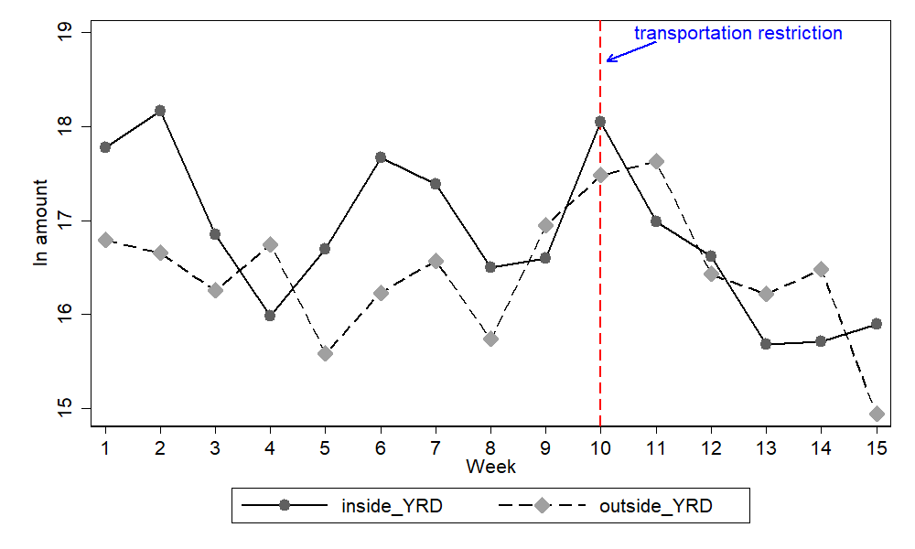 **Figure 2. Trade amount inside YRD vs outside YRD**

Similar to the method, we run the following difference-in-differences regression, to identify if the river shipping amount inside YRD decreases more after the transportation restriction starting date:

$$\begin{aligned}{lnamount}_{it}=α+β_{1}{inside_{YRD}}_{i}+β_{2}{after_{restrict}}_{t}+β_{3}{inside_{YRD}}_{i}*{after_{restrict}}_{t}+ε_{it}\#\left(2\right)\end{aligned}$$

where ${inside_YRD}_{i}$ is a dummy equal to 1 if region *i* is inside YRD, 0 if region *i* is outside YRD. The other variables are defined as in equation (1). The parameter of interest is also $β_{3}$, which captures the difference in the changes in river shipping amount before and after the transportation restriction between inside YRD and outside YRD.

To obtain more precise causal inference, we also identify the effect of transportation restriction using daily-city level data using equation (2), and we further control for the weekend fixed effect and month fixed effect to eliminate the seasonality.

Table 6 reports the regression results based on equation (2). In column (1), we conduct the regression with region-week level data. The coefficient of the double interaction *inside_YRD*\**after_restrict* is -0.716, however, the coefficient is not significantly different from zero even at 10% level. This means the transportation restriction policy does not decrease the river shipping amount inside YRD significantly. In column (2) and (3), we conduct the regression with daily-city level data. We can find that the coefficient of the double interaction *inside_YRD*\**after_restrict* only passes the 10% significance level test even using microdata to inference, indicating that our conclusion based on region-week level is robust.

**Table 6. The effect of YRD transportation restriction: inside YRD vs outside YRD.**

|  |  |  |  |
| --- | --- | --- | --- |
| VARIABLES | lnamount | | |
|  | (1) | (2) | (3) |
|  | Region-Week level | City-Daily level | |
| inside_YRD*after_restrict | -0.716 | -0.311* | -0.322* |
|  | (0.565) | (0.182) | (0.179) |
| inside_YRD | 0.679* | -0.170 | -0.175 |
|  | (0.357) | (0.114) | (0.113) |
| after_restrict | 0.137 | 0.229 | 0.781*** |
|  | (0.399) | (0.139) | (0.189) |
| Constant | 16.391*** | 12.684*** | 13.507*** |
|  | (0.253) | (0.088) | (0.242) |
| Weekend fixed effect | No | No | Yes |
| Month fixed effect | No | No | Yes |
| Observations | 30 | 809 | 809 |
| R-squared | 0.140 | 0.017 | 0.051 |

Notes: Standard errors in parentheses; *** p<0.01, ** p<0.05,* p<0.1.

**4.3. River shipping amount across YRD**

Figure 3 shows the changes in the river shipping amount (logged) across YRD and outside of YRD at region-week level.

We can find that, compared with the river shipping amount outside of YRD, the river shipping amount across YRD is much higher than that outside of YRD before the transportation restriction starting date. But after the starting date, the river shipping amount outside YRD becomes higher than that across YRD in most of weeks.

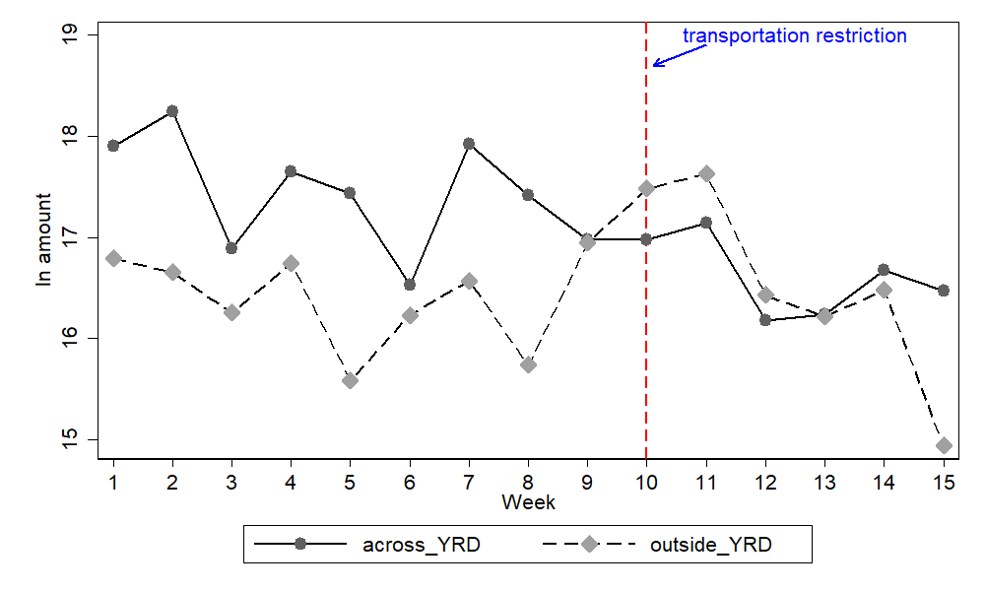

**Figure 3 Trade amount across YRD vs outside YRD**

Similar to the method above, we run the following difference-in-differences regression to identify if the river shipping amount across YRD decreases more after the transportation restriction starting date:

$$\begin{aligned}{lnamount}_{it}=α+β_{1}{across_{YRD}}_{i}+β_{2}{after_{restrict}}_{t}+β_{3}{across_{YRD}}_{i}*{after_{restrict}}_{t}+ε_{it}\#\left(3\right)\end{aligned}$$

where ${across_YRD}_{i}$ is a dummy equal to 1 if region *i* is across YRD, 0 if region *i* is outside YRD. The other variables are defined as in equation (1). The parameter of interest is also $β_{3}$, which captures the difference in the changes in river shipping amount before and after the transportation restriction between regions across YRD and outside YRD.

To obtain more precise causal inference, we also identify the effect of transportation restriction using daily-city level data using equation (3), and we further control for the weekend fixed effect and month fixed effect to eliminate the seasonality.

Table 7 reports the regression results based on equation (3). In column (1), we conduct the regression with region-week level data. The coefficient of the double interaction *across_YRD*\**after_restrict* is -0.962, which is significant at 5% level. In column (2) and (3), we conduct the regression with daily-city level data. We can find that the coefficient of the double interaction *across_YRD*\**after_restrict* is negative and significant at 1% level. More importantly, according to the magnitude of the coefficients in Table 6 and Table 7, we can find that the effect of the transportation restriction policy on the river shipping amount is stronger across YRD than that inside YRD.

Overall, the results above support Hypothesis 2.

**Table 7. The effect of YRD transportation restriction: across YRD vs outside YRD.**

|  |  |  |  |
| --- | --- | --- | --- |
| VARIABLES | lnamount | | |
|  | (1) | (2) | (3) |
|  | Region-Week level | City-Daily level | |
| across_YRD*after_restrict | -0.962** | -0.636*** | -0.665*** |
|  | (0.458) | (0.187) | (0.185) |
| across_YRD | 1.048*** | 0.436*** | 0.446*** |
|  | (0.290) | (0.115) | (0.114) |
| after_restrict | 0.137 | 0.229* | 0.775*** |
|  | (0.324) | (0.136) | (0.190) |
| Constant | 16.391*** | 12.684*** | 13.405*** |
|  | (0.205) | (0.086) | (0.254) |
| Weekend fixed effect | No | No | Yes |
| Month fixed effect | No | No | Yes |
| Observations | 30 | 720 | 720 |
| R-squared | 0.372 | 0.024 | 0.047 |

Notes: Standard errors in parentheses; *** p<0.01, ** p<0.05,* p<0.1.

**5. Conclusions and Implications**

Through comparing Table 5, 6 and 7, we can find an interesting phenomenon: although the shipping amount related to YRD, both inside YRD and across YRD, all decrease, the shipping amount inside YRD does not exhibit a significant decrease. In other words, both H1 and H2 are accepted.

This indicates that the transportation restriction policy does not lead to significant decrease in the shipping amount inside YRD. However, it has a larger impact on the shipping amount across YRD (shipping from YRD to other places and from other places to YRD), which is commonly unexpected.

This means that, of the two types of effects generated by transportation restriction, the long-term/irreversible effect has a greater negative impact on the economy than the short-term/reversible effect. This result verifies that transportation restriction can lead to severe drop in expectation, confidence, and even panic of the future, which decreases the investment demand. This means that the transportation restriction policy itself is not as detrimental to the economy as previous believed. It is people’s decreased expectations and confidence in the restriction policy that plays the major role in the economic downturn.

To our limited knowledge, there are not many related studies on exploring the different mechanisms of the transportation restriction’s impacts on the economy. Therefore, the aforementioned findings have significant academic and practical contributions in the post-epidemic era. It suggests that people need to clearly understand government anti-epidemic measures and rationally make economic activity decision.

**6. Limitations and Future Research**

**6.1. Limitations**

Limited to data time period (15 weeks data), long-term DID vs. short-term DID cannot be applied and compared. As high school students, our knowledge’s limitation is a disservice to our fulfilling more complex task, such us applying river shipping data to anticipate the future economy trend.

**6.2. Future Researches**

We would like to follow the data, and find out long-term changes in river shipping after transportation restriction.And, we would learn more econometric methodology, apply new methods, data, to forecast the economy through river shipping.

**7． References**

Adams-Prassl, A., Boneva, T., Golin, M., Rauh, C., 2020. Inequality in the impact of the corona virus shock: Evidence from real time surveys. Journal of Public Economics. 189, 104245.

Ai, H., Zhong, T., Zhou, Z., 2022. The real economic costs of COVID-19: Insights from electricity consumption data in Hunan province, China. Energy Economics. 105, 105747.

Alexander, D., Karger, E., 2020. Do stay-at-home orders cause people to stay at home? Effects of stay-at-home orders on consumer behavior. Review of Economics and Statistics. 1–25.

Auray, S., Eyquem, A., 2020. The macroeconomic effects of lockdown policies. Journal of Public Economics. 190, 104260.

Birinci, S., Karahan, F., Mercan, Y., See, K., 2021. Labor market policies during an epidemic. Journal of Public Economics. 194, 104348.

Brodeur, A., Clark, A. E., Fleche, S., Powdthavee, N., 2021. COVID-19, lockdowns and well- being: Evidence from google trends. Journal of Public Economics. 193, 104346.

Chen, Q., He, Z., Hsieh, C.-T., Song, Z., 2021. Economic effects of lockdown in China. In: Impact of COVID-19 on Asian Economies and Policy Responses. 3–10, World Scientific.

Coibion, O., Gorodnichenko, Y., Weber, M., 2020. The cost of the COVID-19 crisis: Lockdowns, macroeconomic expectations, and consumer spending. NBER Working Paper No. 27141.

Chen, J., Chen,W., Liu, E., Luo,J. Song, Z., 2022.The Economic Cost of Locking down like China: Evidence from City-to-City Truck Flows .Working paper.

**Acknowledgements**

Transportation Restriction in YRD are piling severe pressures on logistics across the country. Everyone says it is exacerbating the economic fallout. However, is the transportation restriction the only reason driving economic fallout? Or, there are other inner-reasons.

We are interested in finding out the truth. Through the process, we found out the interesting and meaningful feature of the River Shipping transportation which can reveal the net and long-term/irreversible transportation restriction effect on the economy.

Luckily, we found the database of the first and largest platform for mating ships and cargoes across China. We collected all data in this platform from 2022-02-16 to 2022-05-31 at deal level across the whole country, which covered YRD’s transportation restriction.

Meiqian Wu took responsibility of collecting the data, Xiang Wan and Yuquan Xie were in charge of data analysis. All of us did the literature and writing, polishing the draft together.

Professor Wang Yuwei helped us in understanding the link between the logistics industry and the economy. Professor Xu Kaiquan mentored us on how to apply the difference-in-differences (DID) analysis method in the research. We shall express our sincere thanks to them for their tireless and helpful mentoring.

Thanks to the logistic companies we interviewed, their supports are crucial to our research.

Thanks to our parents and teachers, with their encouragement and support, we learned how to grapple with difficulties.